(Approx. 76 words)

Microsoft Windows 10 Tips App
Submitted by Barbara Gravitz, Treasurer, The PCUG-CT
September 2017 issue, The Program
www.tpcug-ct.org
merdoon (at) sbcglobal.net

#1. Do a Bing search “How to use Windows 10 TIPS app”

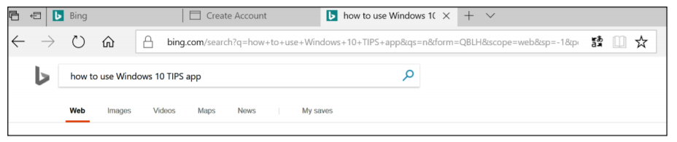

#2 Scroll down until you see the following 3 choices:


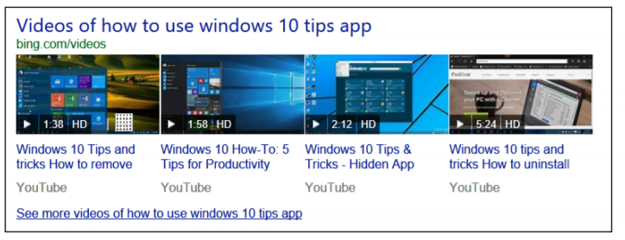

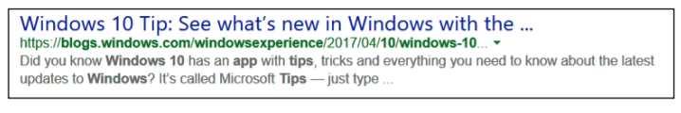
#3 Click on any or all to learn about all the new things that have been added to Windows 10 and how to use them. The Windows Tip app icon looks like this:



